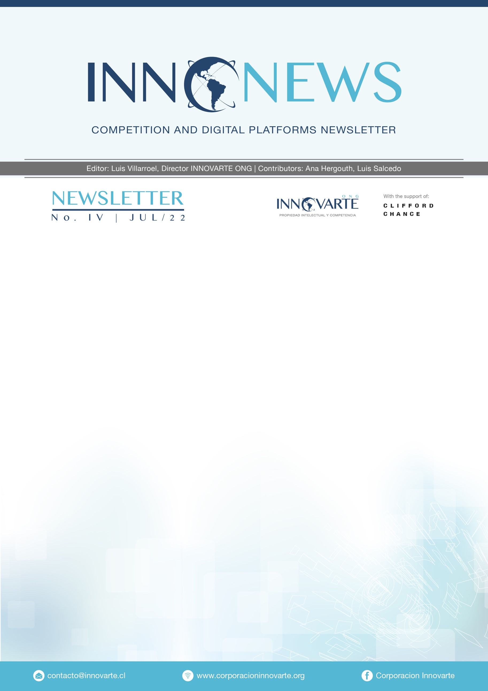

REGULATION

European Union 🇪🇺

16/06/2022

Internal Market Committee endorses agreement on Digital Services Act EP press release
The new rules introduce:
- Landmark standards for a safer and more open digital space for users
- New obligations for platforms, proportionate to their size and societal risks they pose
- Users can report illegal content and platforms will have to act quickly

MERGER CONTROL

European Union 🇪🇺

02/06/2022
Mergers: Commission clears acquisition of Cerner by Oracle
- The Commission concluded that the proposed acquisition would raise no competition concerns given that there are no overlaps between the companies' activities and the merged entity would not have the ability to engage in foreclosure practices.
- While Cerner supplies enterprise applications software and services specifically designed for healthcare providers -including clinical research solutions supporting life sciences companies, Oracle, on the other hand, develops, produces, markets and distributes information technology solutions, including infrastructure software and services, enterprise hardware and enterprise applications software.

ANTITRUST ENFORCEMENT

European Union 🇪🇺

15/06/2022
Abuse of dominance on the LTE chipsets market: the General Court annuls the Commission decision imposing on Qualcomm a fine of approximately €1 billion – Curia press release - (See full text of the Judgement: T-235/18)

- The General Court annulled, in its entirety, the Commission decision to fine Qualcomm for presumptively having abused its dominant position on the worldwide market for chipsets compatible with Long Term Evolution (LTE).
- Its conclusions were based, first, on the finding of a number of procedural irregularities which affected Qualcomm’s rights of defense and, second, on the fact that the analysis undertaken by the Commission in relation to the anticompetitive effects generated Qualcomm’s conduct -offering incentive payments to its customers- did not take into account all relevant factual matters and is, therefore, insufficient.
- An appeal may be brought before the Court of Justice against the decision of the General Court within two months and ten days of notification of the decision.

UK 🇬🇧
10/06/2022
Investigation into suspected anti-competitive conduct by Google
- The CMA is investigating Google’s conduct in relation to the distribution of apps on Android devices in the UK, in particular Google’s Play Store rules which oblige certain app developers to use Google’s own payment system (Google Play Billing) for in-app purchases.

10/06/2022
CMA plans market investigation into mobile browsers and cloud gaming
- The CMA launched a competition law investigation into Google’s rules governing apps’ access to listing on its Play Store, in particular regarding conditions Google sets for how users can make in-app payments for certain digital products.
- Separately, the CMA has an existing competition law investigation underway in relation to Apple’s App Store terms and conditions, which it opened in March 2021.

26/05/2022

Google probed over potential abuse of dominance in ad tech
- The CMA is assessing whether Google’s practices in the ad tech stack may distort competition. These include whether Google limited the interoperability of its ad exchange with third-party publisher ad servers and/or contractually tied these services together, making it more difficult for rival ad servers to compete.
- The CMA is also concerned that Google may have used its publisher ad server and its Demand-side platforms (DSPs) to illegally favour its own ad exchange services, while taking steps to exclude the services offered by rivals.

France 🇫🇷

16/06/2022
Meta makes commitments
- Following a complaint by Criteo in September 2019, the Autorité's investigation services raised competition concerns about a number of practices that could affect competition conditions, on the one hand between the various advertising intermediation service providers, and on the other hand between Criteo and Meta.
- In the context of a negotiated procedure, the companies of the Meta group proposed commitments in June 2021, which were then subjected to a market test and then examined by the Board, who decided to accept such commitments, and made them binding, thus closing the procedure.

Germany 🇩🇪

21/06/2022
Proceeding against Google for possible anti-competitive restrictions of map services (Google Maps Platform)
- The Bundeskartellamt has initiated a proceeding against Google Germany GmbH, Hamburg and Alphabet Inc., Mountain View, USA, with the purpose of examining possible anti-competitive restrictions imposed by Google Maps Platform to the detriment of alternative map services providers, by restricting the possibility to combine Google’s map services with third-party maps.

United States 🇺🇸

16/06/2022
FTC Report Warns About Using Artificial Intelligence to Combat Online Problems
- The Federal Trade Commission issued a report to Congress warning about using artificial intelligence (AI) to combat online problems and urging policymakers to exercise “great caution” about relying on it as a policy solution.
- The report outlines significant concerns that AI tools can be inaccurate, biased, and discriminatory by design and incentivize relying on increasingly invasive forms of commercial surveillance.

03/06/2022
FTC Looks to Modernize Its Guidance on Preventing Digital Deception
- FTC staff is seeking public input to ensure the guides are helping honest businesses treat consumers fairly, rather than being used as a shield by firms looking to deceive. In seeking public comment on possible revisions, staff is interested in the technical and legal issues that consumers, the FTC’s law enforcement partners, and others believe should be addressed.

Australia 🇦🇺

31/05/2022
ACCC focused on competition issues with shift to digital payments
- Competition in payments markets, investigating allegations of anti-competitive conduct, and protecting the interests of consumers will be the focus of the ACCC’s financial services enforcement and policy work over the next year.
- These comments were made by ACCC Chair, Gina Cass-Gottlieb, just one day after the enforcement entity instituted proceedings against Mastercard for allegedly engaging in anti-competitive conduct with the purpose of substantially lessening competition in the supply of debit card acceptance services.

08/06/2022
Airbnb allegedly misled Australians about accommodation prices
- The ACCC has instituted proceedings in the Federal Court against Airbnb, Inc. and Airbnb Ireland UC for allegedly misleading consumers into believing prices for Australian accommodation were in Australian dollars by displaying prices on its website or mobile app for Australian accommodation using only a dollar sign ($), without making it clear that those prices were in US dollars.

Japan 🇯🇵

02/06/2022
Approval of the Commitment Plan submitted by Expedia Lodging Partner Services Sàrl
- The commitment Plan submitted by Expedia Lodging Partner Services Sàrl was approved by the Japan Fair Trade Commission, who considered that the measures are sufficient for eliminating the conducts, and that competition may be promptly restored through the Commitment Procedure.

MARKET STUDIES

UK 🇬🇧

22/06/2022
Music and streaming market study.
- The CMA has launched a market study into music and streaming services. Further responses to the Statement of Scope published and the statutory deadline for publishing market study report is January 26, 2023.

17/06/2022
CMA consumer research into purchasing behaviour in the UK smartphone market
- As part of its market study into mobile ecosystems, the CMA commissioned consumer research into the UK smartphone market.

10/06/2022
Mobile ecosystems market study updated
- Final report and Proposal to make a market investigation reference published.
- The report sets out the CMA’s findings, the concerns that it identified, its assessment of the range of potential interventions that could address them, and finally sets out the action the CMA will be taking now that study has concluded, including the proposal to make a market investigation reference.

BLOGS/ARTICLES

ProMarket: Big Tech ‘Self-Preferencing’ Bills May Hurt—Not Help— Antitrust Reform

Atlantic Council: The EU Digital Services Act and Digital Markets Act could become global models, say the bills’ drafters

Truth on the Market: DMA Update: It’s Still a Privacy Danger

D'Kart: CONGLOMERATE FORECLOSURE IN THE METAVERSE -

Stanford Computational Antitrust: The Adoption of Computational Antitrust by Agencies: 2021 Report

Stanford Computational Antitrust: Relevant Market in the Google AdTech Case

Kluwer blog: Competition Law And Privacy: An Opinion on The Future of a Complicated Relationship
The Digital Markets Act – We gonna catch ‘em all?

Competition Policy International: CPI Tech Reg Chronicle – earlier issues here
- The Taming of Internet Platforms – A Look at the European Digital Services Act By Natascha Just
- Why Tech Regulators Need to Think Like Google By Terry Flew
- What We Talk About When We Talk About Deplatforming Trump By Scott Babwah Brennen & Matt Perault
Aesthetics, Technology, And Regulations By Gregory Day
- Randomized Experiments for Online Content Moderation Policy By Imanol Ramírez
- Platform Content Standardization By Marta Cantero Gamito

PRESS

21/6/2022
Google Maps Faces German Antitrust Watchdog Probe – Competition Policy International

16/6/2022
France accepts Meta’s online advertising commitments – Global Competition Review

26/5/2022
Antitrust Experts Worldwide Discuss Crypto – Competition Policy International

14/06/2022
Meta fails to overturn Giphy sale order by UK competition regulator – Financial Times

CONFERENCES

14/07/2022 (3:30pm - 4:30pm)
BST FTI Consulting Technology Emerging fairness and transparency considerations in Artificial Intelligence
The discussion will cover:
- Understanding the current state of AI adoption and the impact of competition or other legal regimes.
- Balancing AI regulatory considerations with innovation objectives.
- Measuring fairness and detecting bias as models are developed and deployed.
- Best practices in AI governance and ethical use of data.

OPINION

Regulation of digital platforms in Chile: Good and bad ideas

There are many concrete milestones that have been achieved in Chile in recent times and that I believe will contribute to the discussion or possible regulations on issues of free competition and digital platforms.

Certainly, there are pending issues in our country, such as the specific discussion held in Europe and the United States in relation to certain behaviors of the technological giants, which, moreover, Chile could also be affected by behaviors similar to those evidenced today or in the future.

Therefore, it is necessary to make a deeper analysis on this matter by reviewing the main milestones that we can identify so far in our country, which show that we are moving towards a better approach of these issues that mix free competition and digital markets. With the caveat that some have been very good ideas and others, not so good.

- Administrative and Judicial Jurisprudence (FNE / TDLC)

We have limited but important jurisprudence from the National Economic Prosecutor's Office (FNE) and the Court for the Defense of Free Competition (TDLC) regarding some specific cases.

The merger of Uber and Cornershop, for example, was a situation in which the FNE analyzed the importance of data and whether or not it can be a barrier to entry into the affected market. In this case, the Prosecutor's Office ruled out this factor because, in its opinion, the same amount of data could be obtained by other means or through the purchase of such data. Consequently, the FNE concluded, among other aspects, that the merger did not have an entry barrier with respect to data.

On the other hand, we currently have some cases at the TDLC regarding the closure of bank accounts of

Cristián R. Reyes Cid
Abogado de la P. Lawyer from Universidad Católica of Chile, former head of the Legal and Litigation divisions of the National Economic Prosecutor's Office (FNE) and senior counsel at Aninat Abogados.

Chilean banks against companies operating in Chile. This case has been ongoing since 2018 and we expect to obtain a final resolution by the end of this year or early next year. In this regard, I believe it is very important to wait for the decision to be enforced, as we find ourselves in a situation in which traditional market players are increasingly confronted with new players and innovation. For example, in this case, it is alleged that traditional competitors are blocking the entry of new competitors such as cryptocurrency companies, which could offer payment, transfer and investment services, among others.

At the time this case started, our industry and our system did not know much about Fintech or about cryptocurrencies. However, we now have a collected information on the benefits that these new technologies could bring to the market with respect to financial integration, innovation and competition. In that sense, this will be a very important precedent for the analysis of digital platforms in relation to innovation and the digital economy.

Another example in this matter is the entry of Uber in our country, which caused that in two or three cases before the TDLC the guild of traditional cab drivers sued Uber and other similar applications for alleged unfair competition, being finally rejected this accusation by the TDLC, which is currently under review by the Supreme Court.

There are other cases that show the dispute between traditional and new technologies. For example, we have the cases on means of payment since, as technology has advanced, the incorporation of new agents into the market, such as non-bank issuers of payment cards and payment service providers (PSPs), has given more technology to the system, to merchants and to end customers. We therefore expect the TDLC to provide us with some regulation for this market, given the lack of pronouncements from other authorities in this regard.

The outcomes in all these cases will be of utmost importance, as they will provide us with more information on how each market involved in each case will continue and what are the possible criteria to follow in future cases.

- "Guide for the analysis of Horizontal Concentration Operations" - National Economic Prosecutor's Office. Effective as of May 31 of this year.

In parallel, the FNE issued and came into force in the middle of this year a new guide for the analysis of horizontal concentration operations, in which it added many new provisions, specifically in relation to digital markets and platforms, and the criteria that could be used to evaluate operations involving this type of markets.

Undoubtedly, this guide will be very important for the analysis of free competition in Chile, because the guidelines it contains could be applied in other types of investigations or cases against possible violators of the Antitrust Law, even before the TDLC.

- Bills of Law

It is also worth mentioning three bills that are under discussion in the Chilean Congress, one of them recently became law and the other two bills are still under discussion in the Senate of the Republic.

1) Law to regulate digital platform workers (Law No. 21.431).

This new labor law provides a very broad definition of a digital service platform company, defining it as "that organization that, for a fee, administers or manages a computer or technology system executable in mobile or fixed device applications that allows a digital platform worker to execute services, for the users of such computer or technology system, in a specific geographic territory, such as the withdrawal, distribution and/or delivery of goods or merchandise, the minor transportation of passengers, or others". However, Law No. 21.431 expressly states that this concept does not include those platforms that are limited to advertising, services rendered by natural or legal persons, sale or lease of movable or immovable property, among others. For the time being, such platforms will not be considered in the law as platform companies for our labor system.

Although there is an interesting concept of what is understood by digital platforms, this definition is only applicable for labor purposes, although it is useful when reviewing our legal system in this matter and trying to have a definition that is not so diverse in other regulatory applications.

2) Digital Platforms Bill (2021)

Unlike the previous case, this project establishes a broad and ambiguous concept of digital platform, which leaves large areas of uncertainty when understanding these platforms as any digital infrastructure whose purpose is to create, organize and control, by means of algorithms and people, a space for interaction where natural or legal persons can exchange information, goods or services.

In this sense, the bill is very deficient, since -in fact- it includes any digital service of companies that specifically direct their content to Chile, without even distinguishing whether they are State or private services.

This bill even has the negative bias of pointing out that these platforms could be a source of violation of people's rights, which shows that its assumptions are not correct.

In addition, this bill attempts to regulate many rights, thinking that consumers and users of its platforms are very vulnerable and uninformed people. It even seeks to regulate rights that are already established in other national laws (such as data protection, non-discrimination or net neutrality), which reflects its poor legislative technique and the uncertainty that its interaction with other regulations could cause.

3) Chilean Fintech Bill (2021)
A different situation is the Fintech Law project, as it contains a very adequate, studied and complete text, seeking to defend specific principles, such as innovation, competition and financial inclusion. This project is also realistic in trying to regulate specific situations, such as those related to an open finance system (open finance), crypto assets and other Fintech topics that - in the opinion of the sectoral authority - should enter the regulatory sphere.

This bill is still in the Chilean Senate and there are still some debates about data protection, for example, but it is undoubtedly a very good bill, which is expected to come into force by the end of this year.

- Current regulation of digital platforms in Chile

As can be seen, the regulation of digital platforms is not currently centralized, but rather dispersed. From the FNE Guide and the Fintech Law, for example, we can find common and general principles, such as the interconnection between market agents, in order to reduce market power and entry barriers, increase competition and avoid the abuse of giants, encouraging inclusion and innovation.

But the challenge is to try to obtain specific and transversal criteria from the Chilean authorities in this matter, in order to provide greater legal certainty to all those involved. In addition, we are far behind in comparison to the discussion we see in Europe or the United States regarding how certain platforms set demands on developers or breach privacy policies.

I consider it very important to start talking about these issues, since they are problems that we could have in Chile not only in the future, but also today.

Among so many questions, it is worth asking, for example, whether we will have a single definition of digital platforms, whether we will have some general requirements for app stores, or whether we will define how the relationship between personal data regulation and free competition will be. The latter is a very important issue in Germany and other countries.

Will we need to regulate tech giants in advance as is the thinking in the U.S.? In my opinion, that is not necessary. Will it be necessary to request authorization to develop innovations in Chile? According to our Political Constitution, it is not necessary either, since it is not required to obtain an authorization to operate in Chile. So, if there is an innovation that could be an inconvenience for banks or cab drivers, I am sorry, but we are free to perform whichever economic activities we wish.

This is precisely the basis we have to consider to start every analysis and every discussion on these issues.

- Closing remarks

In Chile we have a regulation derived from the Roman tradition, but the antitrust system is a kind of exception that allows us to advance in regulations and measures that do not require rigid structures, such as those found in traditional civil and administrative law.

In this way, I believe that the antitrust system could help Chilean digital markets to have some regulation based on specific cases, so we should not necessarily wait for a law that regulates all these issues.

This could be very similar to what has happened in the telecommunications market. We have a structure and sectorial authorities, but many changes in this market have been derived from antitrust cases followed before the TDLC.

Based on the above, I believe it is very important to observe the jurisprudence of the Prosecutor's Office, the TDLC and also the Supreme Court on these issues. And that the legislator keeps in mind the trends that may appear in this matter, avoiding providing dispersed, incomplete, and eventually contradictory solutions to the principles that are intended to be protected.

* The Opinion expressed in this column does not represent the position of INNOVARTE ONG, being its Author responsible for its content.

Contributions and suggestions are received by e-mail: Write to us: info@innovarte.cl

